HOME
“Wherever the art of medicine is loved, there is also a love of humanity.”
Hippocrates

“There are in fact two things, science and opinion; the former begets knowledge, the later ignorance.”
Hippocrates

"The brain is wider than the sky."
Emily Dickinson

Time is going too fast… memories are the most precious treasure in our lives…
Our mission is make these memories last forever.

We present the first electrostimulating medical device targeting brain structures responsible for memory consolidation.
VGuard is the first non-invasive home use electronic device dedicated specially for patients suffering from Alzheimer's disease to boost memory and make their life easier.
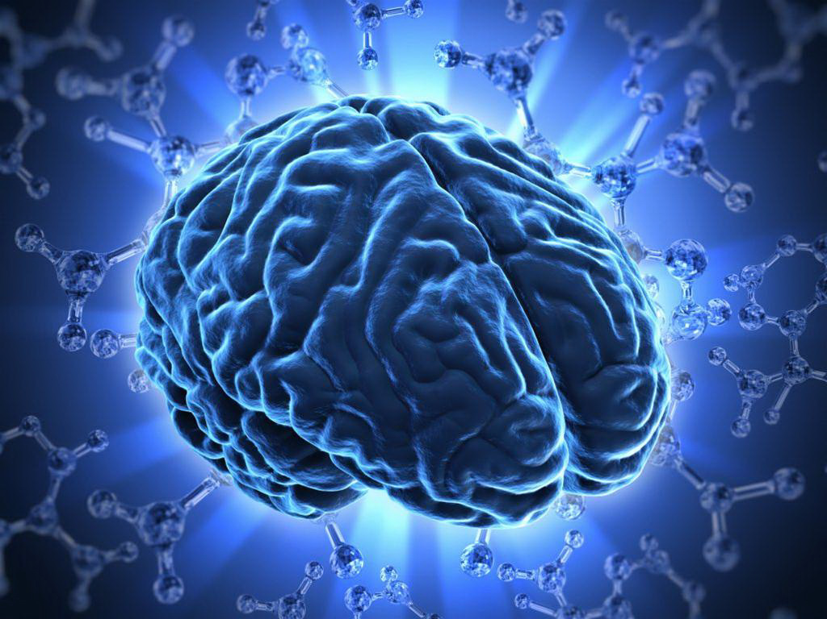


The VGuard device is dedicated for patients with mild cognitive impairment (MCI), specially for patients with Alzheimer’s disease or dementia above 60 years old.
VGuard device will be a pioneering solution on a global scale, introducing a new method of therapy delaying the development or reducing symptoms of the disease. VGuard consists of a headband with a built-in neurostimulator. What is important VGuard device will be working in wireless bluetooth connection to personal mobile devices, what gives great opportunity to monitor treatment compliance.

TECHNOLOGY

Vagal nerve stimulation (VNS) has been used in clinical practice for more than 20 years. In our project we combined best clinical experience comming from that method with innovative approach to stimulation and as a result we target human brain structure involved in memory consolidation in non-invasive way. Those structures are heavily affected by neurodegenerative process of Alzheimer’s disease: hipocampus, amygdala, locus coareleus. By long term animal trial we are able to establish most effective stimulation protocols and those results were confirmed on human in fMRI (functional magnetic resonance imaging).
Vagal nerve as a stimulation target was selected per purpose due to its role in maintaining of humans homeostasis. It was already proven in other clinical application that vagal nerve stimulation can be effective tool in treatment of various neuropsychiatric disorders eg. epilepsy, despresion, migraine.

COMPANY
- ABOUT US
The company was founded in 2014 by an international team of experts in the field of neurology, neurophysiology, psychiatry and medical engineering supported by experienced managers. For unique achievements project was recognised by European authorities and granted from European Union Funds.

- PROJECT TEAM

- Dr. Tamir Ben David – Main Project Engineer
PhD in Physics, MBA from Tel Aviv University.
Dr Ben David brings over 18 years of top management experience in the medical devices development field and venture capital, including Orad, BioControl, BSP, OB-Tools, Virtual Ports and IHCV. Dr. Ben David filed more than 90 patent applications in the field of medical technologies. Dr. Ben David Holds a Ph.D. in Physics and an MBA from Tel Aviv University.

- Dr. Adam Broncel – Medical Director
PhD in medicine, Medical Doctor, Neurologist.
Dr. Broncel graduated from Medical University of Lodz in Poland and postgraduated studies in Berkeley, CA, USA. Reveived PhD in the field of neurology. He is conducting international research projects in the field of experimental neuroscience.

- Raanan Gefen – Project Engineer
…, MBA from Tel Aviv University
Mr Gefen specializes in R&D management of ground breaking ventures over more than 30 years, 15 of which in the medical device arena. Raanan led the development of NanoRetina, miniature artificial retina prosthesis, among others. He is the inventor of more than 30 registered patents and many more patent applications in various medical disciplines.

- Agnieszka Jarecka - R&D Project Development Manager
MSc in the field of marketing and management. Ms. Jarecka has more than 10 years' experience in management of R&D international projects. Since 2015 has received and managed three R&D grants for life science projects.

- Dr. Kamila Kulbat – R&D Project Assistant
PhD in biotechnology, Biologist
Dr Kulbat graduated from University of Lodz, Faculty of Biology and Environmental Protection and obtained PhD in the field of biotechnology from Lodz University of Technology (Poland). Dr Kulbat has experience in research work gained during internships at the University of Natural Resources and Life Sciences in Vienna (Austria) as well as at the Cyprus University of Technology. Author and co-author of several publications. 2 years of experience in R&D projects.

- Dr. Paulina Kłos-Wojtczak – Neurophysiologist
PhD in the field of neurobiology, Biologist
Neurobiologist and medical biotechnologist. Dr Kłos-Wojtczak has got experience in research work in the field of neurobiology, especially electrophysiology of brain. She had internships in Biomedicum Helsinki (Finland), pharmaceutical companies (Medana. S.A.) and attended prestigious science camps organized by FENS Organizations. Co-author of scientific, experimental papers. Dr Kłos-Wojtczak is a scientific journalist writing for several polish magazines.

- Wojciech Białecki – Project Engineer
Biomedical Engineer spec. medical electronics and textronics
Graduated from Technical University of Lodz, Department of Bio…..

- Prof. Jan Konopacki – Neurophysiology Scientific Investigator
Professor, PhD in the field of neurobiology
Prof. Konopacki is an expert in neurophysiology in the Department of Neurobiology at University of Lodz. He also has served as a Neuroscience professor and visiting researcher at the University of Calgary, Canada. He is the author or co-author of over 190 publications. Researech topics include: neuroanatomical, neuro-electrophysiological and neuro-pharmacological substrate of brain oscillatory activity and neurodegenerative diseases.

- Prof. Piotr Gałecki – Main Clinical Investigator
Professor, PhD in medicine, Medical Doctor, Psychiatrist
Psychiatrist, academic teacher and practitioner. Head of the Department of Adult Psychiatry, Medical University of Lodz. National consultant in the field of psychiatry. Author and co-author of over 300 publications, including combining of psychiatry and psychology.
RESEARCH

- Alzheimer's disease in the world
Alzheimer’s disease (AD) is a degenerative brain disease and the most common couse of dementia resulting in significant problems with memory, thinking and behaviour. Symptoms of Alzheimer’s disease develop slowly but systematically and get worse over time. With age symptoms become sever enough to interfere with daily activities. Statistics say that AD is the 6th leading cause of death in the USA. One out of ten (what gives 10% of population) elderly above 65 years old suffer from Alzheimer’s disease. 1 in 3 seniors dies with dementia.
Source: Alzheimer's Association® https://www.alz.org/
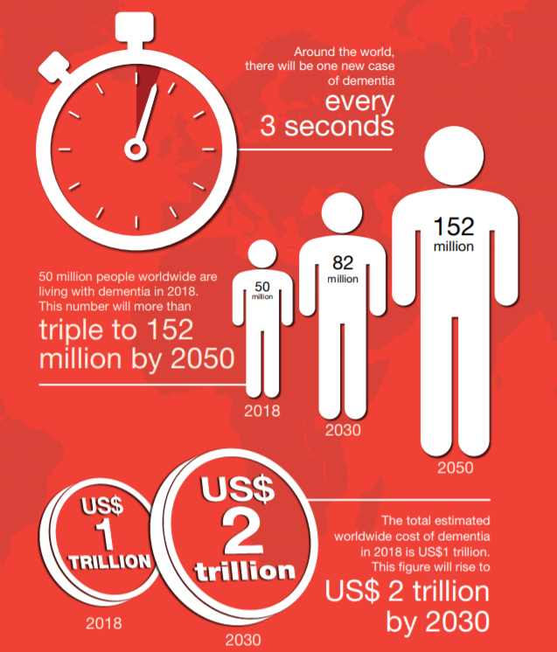

According to World Alzheimer Report 2018 50 million patients are living with dementia worlwide. As people live longer the number of seniors suffering from dementia is rising rapidly all over the world. By 2050, this population will triple.
Currently there is no effective treatment of Alzheimer’s disease. Applied pharmacological therapies do not bring the expected result. Ongoing research put an efford to find better treatment to dalay progression of the disease.

- Short story
Already ancient Greeks and Romans associated aging with the deterioration of memory, but they did not know possible reasons. In 1906 the German psychiatrist, Dr. Alois Alzheimer for the first time described the case of a disease in woman who had died with undefined neurological symptoms including memory problems along with language impairment and unpredictable behavior. The brain autopsy showed extensive atrophy of the cortex (pathologically thin gray matter) and two types of abnormal deposits inside (now known as amyloid plaques) and between neurons (now called neurofibrillary tangles). Till today this neurodegenerative disease is carrying his name.

- About Alzheimer’s disease
As Alzheimer's is a progressive neurological disease, symptoms worsen over time, but quality of life and expected lifetime after diagnosis may vary depending on may factors.
Neurodegenerative changes in the brain begin years before any noticible symptoms of the Alzheimer's disease. This period of time is called preclinical stage of Alzheimer's disease.
First symptoms are often mistakenly attributed to aging or stress. Detailed neuropsychological tests may reveal mild cognitive impairment up to eight years before the patient meets clinical criteria for AD diagnosis. The most visible is the loss of fresh memory in the form of difficulties in recalling recently remembered facts and inability to memorize new information
www.alzheimers.org.uk
- Bäckman L, Jones S, Berger AK, Laukka EJ, Small BJ. Multiple cognitive deficits during the transition to Alzheimer's disease. „J Intern Med”. 256 (3), s. 195–204, 09 2004.
- Nygard L. Instrumental activities of daily living: a stepping-stone towards Alzheimer's disease diagnosis in subjects with mild cognitive impairment?. „Acta Neurol Scand”. Suppl (179), s. 42–6, 2003.
- Arnáiz E, Almkvist O. Neuropsychological features of mild cognitive impairment and preclinical Alzheimer's disease. „Acta Neurol. Scand., Suppl.”. 179, s. 34–41, 2003.

- Publications

1. Broncel A., Bocian R., Kłos-Wojtczak P., Konopacki J. 2018. Medial septal cholinergic mediation of hippocampal theta rhythm induced by vagal nerve stimulation. Plos One. 5;13(11).
2. Broncel A., Bocian R., Kłos-Wojtczak P., Konopacki J. 2018. Some technical issues of vagal nerve stimulation. An approach using a hippocampal formation theta rhythm. Brain Res Bull. 140:402-410.
3. Broncel A., Bocian R., Kłos-Wojtczak P., Konopacki J. 2017. Vagus nerve stimulation produces a hippocampal formation theta rhythm in anesthetized rats. Brain Res. 1675:41-50.

- Conferences

BrainTech 2019 ….

CONTACT
Neuromedical Sp. z o.o.
Natolin 15
92-701 Łódź, Poland

